**Website profiling**

1. What can you say about the current infrastructure / environment in place?

Technologies used (whatruns browser plugin)

===CMS===

TYPO3 CMS 6.1

Mousewheel JS

===Web Framework===

Bootstrap

===Programming Language===

PHP 5.3.3

Advertising

AppNexus

===Google AdWords===

AdNexus

===Javascript Frameworks===

jQuery 1.8.2

Jquery Easing

===Font Script===

Font Awesome

Google Font API

===Web Server===

Apache 2.4.33

===Sales and Marketing===

Optimizely

===Tag Managers===

Google Tag Manager

1. What measures of performance optimization can you identify? Which additional measures for performance optimization could be added?

Below static content especially images could be loaded from CDN such as Akamai/Adobe scene 7.

https://bat.bing.com/bat.js

https://www.zinspilot.de/fileadmin/_processed_/csm_Creditplus_logo_af31155432.png

https://www.zinspilot.de/fileadmin/_processed_/csm_Logo_Datenschutz_83de02c69e.png

https://www.zinspilot.de/fileadmin/_processed_/csm_Logo_Hamburger_Abendblatt_c7ac320c39.png

https://www.zinspilot.de/fileadmin/_processed_/csm_Logo_Sueddeutsche_Zeitung_4a690bd54a.png

https://www.zinspilot.de/fileadmin/_processed_/csm_WELT_Kachel_rgb_30c03f5b46.png

https://www.zinspilot.de/fileadmin/_processed_/csm_fimbank_730c9feb99.png

https://www.zinspilot.de/fileadmin/bilder/de_flag.png

https://www.zinspilot.de/fileadmin/bilder/icons/einlagensicherung.png

https://www.zinspilot.de/fileadmin/bilder/icons/postident.png

https://www.zinspilot.de/fileadmin/bilder/icons/zinspilot-konto.png

https://www.zinspilot.de/fileadmin/sys/img/flags/de.png

https://www.zinspilot.de/fileadmin/sys/img/flags/mt.png

https://www.zinspilot.de/fileadmin/sys/img/flags/roma.png

https://www.zinspilot.de/fileadmin/sys/img/icon_phone.png

https://www.zinspilot.de/fileadmin/sys/img/teaser_bg_left.png

https://www.zinspilot.de/fileadmin/sys/img/teaser_bg_middle.png

https://www.zinspilot.de/fileadmin/user_upload/BankingCheck_Award_Siegel.png

https://www.zinspilot.de/fileadmin/user_upload/Focus_Money2016.jpg

https://www.zinspilot.de/fileadmin/user_upload/hshnordbank_logo.png

https://www.zinspilot.de/fileadmin/user_upload/logo_alpha_bank_160x34.png

https://www.zinspilot.de/uploads/RTEmagicC_BankingCheck_Award_Siegel_subcopy_01.png

https://www.zinspilot.de/uploads/RTEmagicC_anlagevolumen.png

https://www.zinspilot.de/uploads/tx_sdcontent/bankplakette_Atom_Bank.png

https://www.zinspilot.de/uploads/tx_sdcontent/bankplakette_aab_17.png

https://www.zinspilot.de/uploads/tx_sdcontent/bankplakette_big.png

https://www.zinspilot.de/uploads/tx_sdcontent/bankplakette_cbl_06.png

https://www.zinspilot.de/uploads/tx_sdcontent/bankplakette_closebrothers.png

https://www.zinspilot.de/uploads/tx_sdcontent/bankplakette_rietumu.png

https://www.zinspilot.de/uploads/tx_sdcontent/slideshow_FIM_zinserhoehung.png

https://www.zinspilot.de/uploads/tx_sdcontent/slideshow_HSH.png

https://www.zinspilot.de/uploads/tx_sdcontent/slideshow_Top_zins_Alpha_01.png

https://www.zinspilot.de/uploads/tx_sdcontent/teaser_slideshow_zp_einfache_loesung.png

**Another suggestion is to minify javascript files.**

https://www.zinspilot.de/fileadmin/sys/js/custom.js?1513937421

https://www.zinspilot.de/fileadmin/sys/js/jquery.cookie.js?1427368717

https://www.zinspilot.de/fileadmin/sys/js/jquery.fancybox-media.js?1426505527

Minification helps web servers to load js files faster and are space efficient.

1. What is the change in latency if the page is requested from different locations across Germany? What could be done to improve the current situation?

**Request from Sweden:**

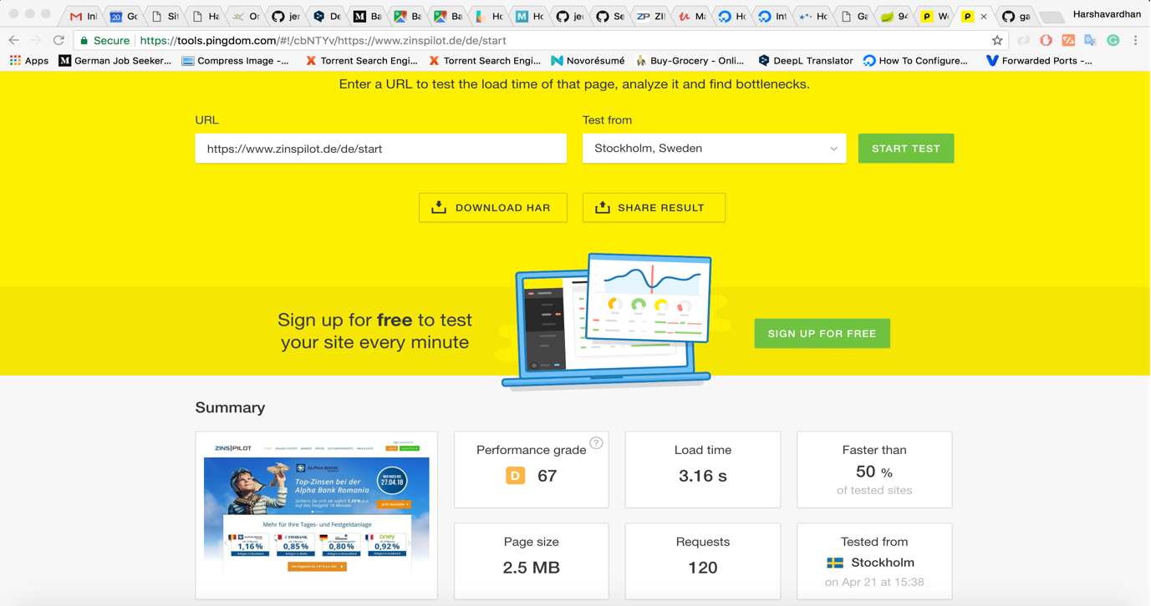

**Request from Australia:**

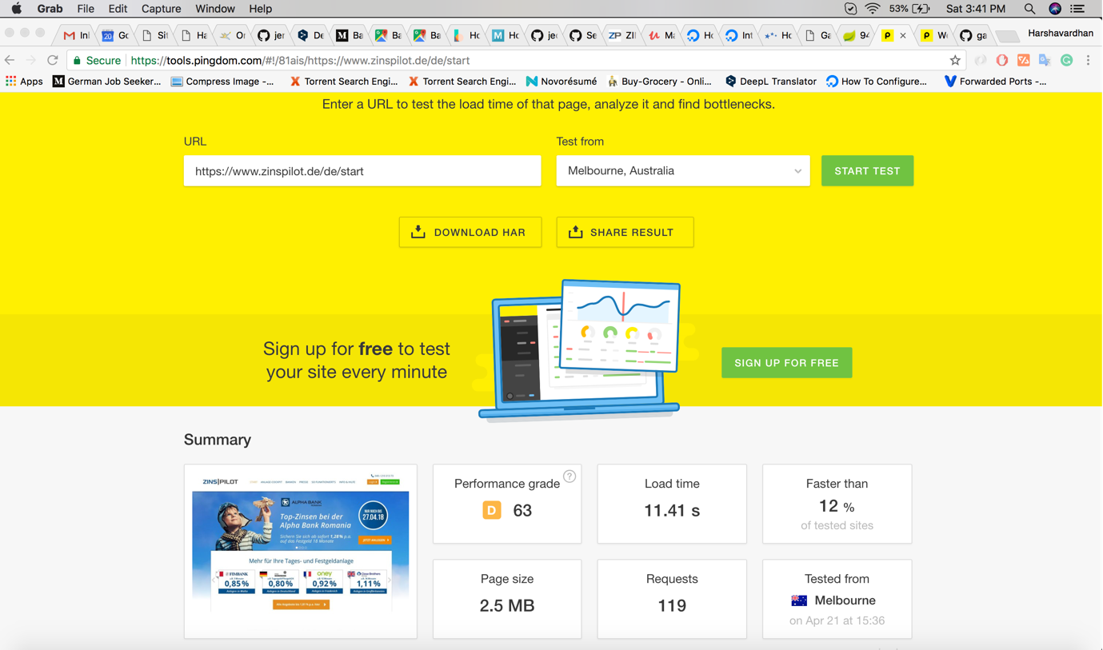

I've attached the images of the requests made from Swedan & Australia.

There is a huge latency in DNS lookup & connect time when the request was made from Australia. I think this should be fixed by minimising the DNS lookups. Of course, it's wise to check with network infra team to know where the actual delay is introduced and apply appropriate fix.